ORIGN:
Design Document

Design Document
Version 1 - 05/09/2018

Document Overview:
The purpose of this document is to detail the development and contents of the ORIGN (working name) lab. ORIGN is an acronym for Open Reproducible Imaging Genomics Neuroinformatics
Key words: Open Science, Reproducibility, Brain Imaging, and Imaging Genetics, Analyses Methods for Neuro/Braininformatics.

Document Contact Persons:
This draft was prepared by Derek Lo 3design.dkl@gmail.com, and is written for internal purposes only. Much of the information contained herein are conceptual ideas for website design and implementation and are subject to change as the project develops.
Table of Contents
ORIGN: Design Document 1
Design Document 1
Document Overview: 1
Document Contact Persons: 1
ORIGN Overview: 2
Project Overview: 2
Design Brief: 2
Overview: 2
Proposed Sitemap: 2
Web Pages: 2
Projects: 2
Website hosting and additional details: 3
Design inspirations: 3

ORIGN Overview:
ORIGN is a lab headed by JB Poline. The mission of this lab is:
“paste mission here”

Project Overview:
This project is to create a website and web presence for the ORIGN lab.

Design Brief:

Overview:
The website will consist of a home page and several internal pages. The focus of this website will be to inform the user about national and international connections with other labs and universities, as well as important projects and products that come out of the lab.

Proposed Sitemap:
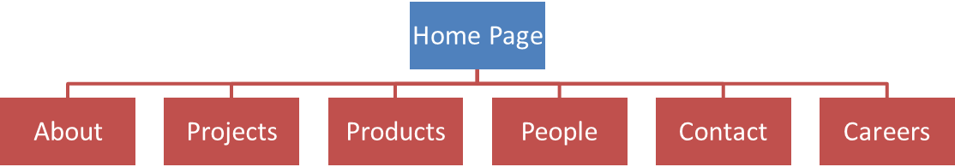

Web Pages:

Homepage:
The homepage will be the most common page visited by new and returning users. The goal of the page is to give an overview of the lab, mission statement, highlight projects and products, and show collaborations with other labs and universities. From this page and through the menu, the user can navigate to sub pages.

About:
The about page will contain an expanded version of the mission statement, as well as objectives and goals of the lab. Additionally, this page can provide more information about collaborations with other labs and universities.

Projects:
The projects page will include a list/table of past, current, and future projects the ORIGN is involved in. Each of these projects could be represented by a logo, project title, project description, and a CTA to portal out to the appropriate project website. Projects that do not have their own dedicated website could potentially be presented as an additional page linked from the projects page.

Products:
The products page will include a list/table of past, current, and future products that were created by the lab, or in collaboration with other labs/universities. A sample of the products that could be represented here are:
- Courses
- Publications
- Training
- Libraries
- Software

People:
The people page will be a list/table the shows those who are a part of ORIGN lab. This would include the head of the lab, as well as any students and others who are employed by ORIGN.

Contact:
The contact page will contain information about ORIGN lab how a user could contact them. The following features or information may be included on this page:
- Contact Form
- Email address
- Google Map (or similar)
- Social media links such as
  - Twitter
  - Linkedin
  - Facebook
  - Orchid
  - Google Scholar

Careers:
The careers page will host opportunities for employment, partnership with the ORIGN lab. This may be links to the McGill website, or possible be PDF’s or similar files. Alternately, a template can be made for all job postings that would then be duplicated and altered as needed.

Website hosting and additional details:
Currently the website will be hosted on GitHub to allow for easy access and updating. A CMS will not be used for this project, however that may change for future expansion. Registering a domain is recommended but is not needed for launch.

Design inspirations:
The final look of the website will be inspired by the following:
- http://mchi.mcgill.ca/projects/
- http://p3g.org/
- https://www.ga4gh.org/
- https://bids.berkeley.edu/
- https://bids.berkeley.edu/people/st%C3%A9fan-van-der-walt
- http://aosabook.org/en/index.html (images)

